TACT: Trust-Anchored Confidence Tempering for
Self-Consistency Voting in Large Language Models
Wei-Chen Ko (柯瑋宸, vito1317)
Independent Researcher

Abstract
Confidence-weighted self-consistency improves on majority voting when a frozen model’s self-reported confidence is calibrated in direction. Every published scheme is monotone increasing in confidence, so an anti-correlated channel poisons the vote, and binary calibration gates survive inversion only by discarding discriminative signal. tact derives the vote exponent from the measured, signed, within-item discrimination of the channel: a pooled van Elteren Somers’ $D$ with an item-clustered standard error, positive-part James–Stein shrinkage, and a Bayes-discriminant link, which at the default base rate $\overset{‾}{p}=1/2$ collapses to $γ=z\sqrt{2+z^{2}}$ with $z$ the probit of the shrunk pooled AUC. Inside the shrinkage dead zone the vote is bit-identical to plain self-consistency. A label-free variant estimates the sign from agreement pseudo-labels under an attenuation identity that guarantees sign consistency while the plurality-error rate stays below one half; past that boundary it mis-signs, which the paper measures and reports. On a synthetic-oracle harness it recovers anti-correlated channels that pin every published protocol to the majority floor ($1.000$ vs. $0.762$) and cracks the heterogeneity floor with zero paired losses ($0.923$ vs. $0.785$). Against a dev-picked signed grid, which the sweep shows is a far stronger baseline than the published protocols, the advantage narrows to distortion, echo, and label-free operation. Two real-trace campaigns then bound the setting: the channel is null on saturated benchmarks ($z=−1.24$) and positive on competition mathematics ($\hat{D}=+0.250$, $z=+2.54$), yet the stratum any such method can act on measures $2.5$–$7.5\%$ of items across five substrates in two domains, so abstention is the correct default and the dead zone implements it.
Keywords— large language models, self-consistency, confidence calibration, label-free estimation, rank statistics

Introduction
Self-consistency (sc) [1] improves the reasoning accuracy of a frozen large language model (LLM) by sampling $K$ chain-of-thought traces and returning the plurality answer. Each trace can also report a confidence score, verbalized [2,3], derived from token log-probabilities, or elicited as $P(\text{True})$ [4], so weighting votes by confidence is a natural refinement. Confidence-Informed Self-Consistency (CISC) [5] showed that this recovers the accuracy of plain sc at a fraction of the sampling budget, and introduced Within-Question Discrimination (WQD) to argue that discrimination, not calibration, is the property that makes a confidence signal useful for voting.
This refinement carries a structural fragility that, to the best of our knowledge, no published method addresses. Every existing weighting scheme is monotone increasing in confidence, including CISC’s softmax weights, reliability-aware pseudo-counts [6], and warmup-thresholded filtering [7]. The trust decision is which magnitude of up-weighting to apply; the possibility that the channel is anti-correlated with correctness is never searched for. Yet miscalibration of direction is not exotic: reinforcement fine-tuning is known to distort verbalized confidence, distribution shift can invert a signal that was informative in-domain, and in the experiments reported here a simple anti-correlated channel ($κ=−0.6$; Section 3) drives confidence-weighted baselines from near-perfect accuracy to far below the majority-vote floor, while the same evidence, read with the correct sign, is a perfect signal. The defensive alternative, a binary dev-set gate that disables the channel when calibration error is high, survives the inversion but discards discriminative signal wholesale: a systematically under-confident yet perfectly ranked channel fails an ECE gate for reasons irrelevant to voting utility [5,8].
This paper frames the problem as estimating one scalar: the signed within-item discrimination of the confidence channel, and mapping that scalar, with its uncertainty, to a vote exponent. The contributions are:
C1: Signed, analytically-tempered weighting. tact votes with $w_{i}=exp(γφ_{i})$, where $φ_{i}$ is the standardized van der Waerden score of trace $i$’s within-item confidence midrank and $γ$ is derived, not grid-searched: a pooled van Elteren Somers’ $D$ (equal to $2⋅WQD−1$) with an exact tie-corrected null variance and an item-clustered jackknife standard error, shrunk by positive-part James–Stein with a significance floor, then mapped through a Bayes-discriminant link. Two anchors are exact: inside the dead zone the vote is bit-identical to sc via a shared code path, and the log-value feature map reproduces CISC-power. Since $φ$ uses only within-item ranks, the method is invariant to every strictly monotone distortion of the confidence scale, and under compression it beats the best exponent in the tested grid $\{0.25,0.5,1,2,4\}$ ($1.000$ vs. $0.963$; that optimum sits at the largest exponent tried, so the comparison bounds the grid, not the family).
C2: Label-free estimation of the sign. The crowdsourcing lineage estimates reliability from cross-annotator covariance [9,10]; one exchangeable channel from one model offers no such structure. tact estimates the signed discrimination from deduplication-weighted agreement pseudo-labels under a proven class-conditional-noise identity, $E[{\hat{D}}_{g}]=(1−2\overset{‾}{ρ})D$: while the pair-weighted plurality-error rate $\overset{‾}{ρ}$ is below $1/2$ the estimate can only under-trust, never mis-sign. A split-half inversion de-attenuates conservatively and sign-aware alarms return the method to sc at the identifiability boundary. Past $\overset{‾}{ρ}=1/2$ it does mis-sign, which Section 9 measures rather than assumes away.
C3: An impossibility result and its structured escape. With i.i.d. per-item coupling and no observable covariate, per-item label-free adaptation is closed: any monotone use of an item’s own agreement statistic collapses to plurality reinforcement, the observable sign opposes the truth on $96\%$ of the plurality-wrong items with $|D_{q}|>0.3$, the ones where a flip could win, and $\{κ>0,\text{minority right}\}$ and $\{κ<0,\text{plurality right}\}$ induce the same observable law. Indexed instead by an observable covariate, the same estimator run per group recovers each group’s signed coupling with zero paired losses to sc (Section 6).
C4: A pre-registered falsification protocol. Four falsifiers were fixed before implementation, two of them designed to kill the method: the published dev-calibrated CISC protocol, whose tuned temperature already interpolates sc$↔$CISC, and a dev-picked signed exponent grid, which the sweep shows is far the stronger of the two. All four survived, and the margins are reported both ways: against the signed grid the advantage concentrates in distortion, echo, and label-free operation, and tact trails it in the mid-range.
C5: A measurement of the addressable stratum. Two real-trace campaigns and a five-substrate window measurement bound what any label-free aggregation method can do. The channel is null on saturated benchmarks ($\hat{D}=−0.219$, $z=−1.24$) and positive on competition mathematics ($+0.250$, $z=+2.54$), so the premise holds where the model is uncertain; but the stratum such a method can act on is $2.5$–$7.5\%$ of items across all five substrates, in two domains, and does not widen as items harden. On both real substrates the in-pool oracle itself cannot clear the pre-registered endpoint, which makes abstention the correct default rather than a conservative one.

Related Work
Confidence-weighted self-consistency. sc [1] treats sampled traces as i.i.d. votes. CISC [5] weights votes by softmax-normalized confidence with a temperature tuned on a labeled split, and its WQD metric makes the discrimination-vs-calibration point that also motivates this work; the rank-calibration line [8] reaches the same conclusion independently. Weighted variants [11] and early-stopping families [12,13] refine the budget. Self-certainty [14] is the closest relative in spirit, being the one published selector that scores candidates by a rank-like quantity rather than by raw confidence, but it ranks across candidates with a fixed positive orientation and is not evaluated here; reliability-aware pseudo-counts [6] and warmup-thresholded filtering [7] adapt online but only re-scale positive trust. None of these searches a negative exponent: the obstruction is a sign bit in the hyperparameter grid rather than the weight family itself, as this paper’s own SignGrid-dev baseline shows by opening the same $c^{γ}$ family to negative $γ$ and reaching the signed oracle across the negative half-axis. What no published protocol does is estimate that sign, with or without labels. The dev-calibrated variant must therefore be positioned honestly: CISC’s tuned temperature is already a dev-calibrated sc$↔$CISC interpolation, so the novelty of tact-dev lies in the sign, the rank invariance, and the analytic (grid-free) map, not in dev calibration itself.
Reliability estimation without labels. Estimating worker reliability from agreement is classical [9,15,16]; spectral meta-learners [10] and recent LLM ensemble work [17,18] exploit covariance across multiple predictors. The setting here differs: one exchangeable channel from one model, per-item vote structure, and the known failure of agreement proxies under correlated errors—met here with a quantified attenuation identity, conservative de-attenuation, and alarms in place of an unconditional claim.
Shrinkage and rank statistics. The estimator assembles classical parts: stratified rank statistics [19], the James–Stein positive-part estimator [20], effective-sample-size corrections [21,22], and normal-scores discriminant analysis. The claim is the assembly and its anchors, not the parts.
Honest sibling result. A preceding system in the same line of work (RLEV-VoI, redundancy-discounted voting with value-of-information stopping) was evaluated under the same falsification discipline and failed it, dominated everywhere by a simple deduplication baseline, and is reported as a negative result. Its post-mortem isolated the confidence dilemma studied here.

Problem Setup

Notation
Items $q=1,…,Q$; item $q$ has $m_{q}$ sampled traces. Trace $(q,i)$ yields an answer $a_{q,i}$ in a discrete set and a confidence $c_{q,i}∈(0,1)$; correctness is $y_{q,i}=1[a_{q,i}=a_{q}^{*}]$, unobserved at test time. Plain sc returns $arg\max_{A}n_{q}(A)$ where $n_{q}(A)$ counts votes for answer $A$. CISC-power weights votes by $c_{q,i}^{ γ}$ with a fixed $γ>0$.

The confidence dilemma
The synthetic oracle draws, per item, traces from a cluster mixture with a latent correct answer and generates confidence as
$$c_{q,i}=clip​\left(1/2+κ (y_{q,i}−1/2)+ε_{q,i}, 0.01, 0.99\right),$$
with noise $ε∼N(0,{0.1}^{2})$ and coupling $κ∈[−0.6,0.6]$. Fig. 1 maps the baseline landscape before the proposed method existed: unconditional weighting (CISC, $γ=1$) collapses on $κ<0$; an ECE gate never opens off the well-calibrated diagonal; a sign-corrected AUC gate over dev labels nearly saturates the homogeneous sweep. This pre-measurement fixes where a new method can legitimately claim wins—monotone distortion of the confidence scale, covariate heterogeneity, small dev sets, and label-free operation—and the evaluation holds itself to exactly those cells.
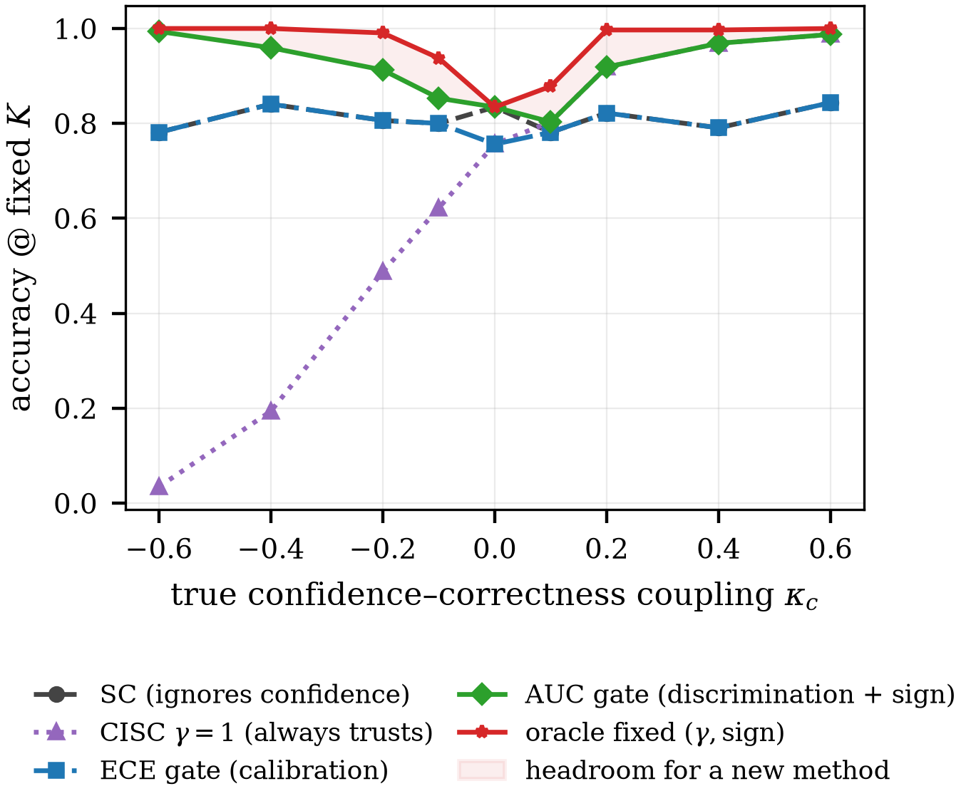
The pre-measured problem statement: accuracy of baseline confidence policies at fixed $K=15$ as the true coupling $κ$ varies. A trivial sign-corrected AUC gate (green) nearly saturates the homogeneous sweep; the headroom for any new method (shaded) concentrates in the mid-range and, off this plot, in distortion, heterogeneity, and label-free cells.

TACT

Vote family
Within item $q$, let $R_{q,i}$ be the midrank of $c_{q,i}$ (ties averaged) and
$$φ_{q,i}=\frac{v_{q,i}−{\overset{‾}{v}}_{q}}{σ_{q}}, v_{q,i}=Φ^{−1}​\left(\frac{R_{q,i}}{m_{q}+1}\right),$$
where $σ_{q}$ is the realized standard deviation of $v$ within the item (the no-tie value is $0.62$ at $m=4$ but $0.95$ at $m=40$; a closed form would silently rescale $γ$ across budgets), and $φ≡0$ if $σ_{q}≤{10}^{−8}$ (all-tied confidences vote as plain sc). The vote is
aq=argmaxAi: aq,i=A​expγ φq,i,
and when $γ=0$ the implementation calls the sc routine itself, making the zero-trust anchor bitwise exact rather than equal in distribution. Because [eq:vdw] depends on $c$ only through within-item ranks, every strictly monotone distortion of the confidence scale leaves [eq:vote] unchanged.

Reliability statistic
For item $q$ with $n_{q}^{1}$ positive and $n_{q}^{0}$ negative labels (dev: $y$; label-free: the pseudo-label of Section 5), the Mann–Whitney statistic on midranks gives
$$D_{q}=2 {AUC}_{q}−1, {AUC}_{q}=\frac{U_{q}}{n_{q}^{1}n_{q}^{0}},$$
which equals $2⋅{WQD}_{q}−1$ in CISC’s notation. Pooling uses van Elteren pair-count weights $N_{q}=n_{q}^{1}n_{q}^{0}$ [19]:
D=q​NqDqq​Nq.
Under the within-item exchangeability null, $U_{q}$ has the exact tie-corrected variance nq1nq0(mq+1)/12⋅[1−t​(t3−t)/(mq3−mq)], yielding a null standard error ${SE}_{0}$; between-item heterogeneity is captured by the closed-form delete-one-item jackknife ${SE}_{J}$. The conservative choice is
$$SE=max\left({SE}_{0}, {SE}_{J}, 1/{2\sqrt{N}}\right), r=\hat{D}/SE.$$
Because $D$ is a pairwise functional, $E[\hat{D}]$ does not depend on $m_{q}$: an exponent estimated at $m=40$ transfers to deployment at $m=8$.

Tempering map
Shrinkage. Positive-part James–Stein with a significance floor $ν$:
$$\tilde{D}=sign(\hat{D}) max​\left(0, |\hat{D}|−ν^{2}{SE}^{2}/|\hat{D}|\right),$$
with dead zone $\{|r|≤ν\}$; $ν_{dev}=1.28$, $ν_{LF}=2.33$. With $ν=1$, [eq:js] is exactly the empirical-Bayes posterior mean under a $N(0,τ^{2})$ prior with plug-in ${\hat{τ}}^{2}=max(0,{\hat{D}}^{2}−{SE}^{2})$ [20]. The map is odd, continuous, never exceeds $|\hat{D}|$, and is monotone in $\hat{D}$ and anti-monotone in $SE$.
Link. Model $φ | y∼N(μ_{y},s^{2})$ within item with the mixture standardized to unit variance, which is what [eq:vdw] enforces, so $s^{2}=1/(1+\overset{‾}{p}(1−\overset{‾}{p})u^{2})$ where $u=\sqrt{2} Φ^{−1}​\left({1+\tilde{D}}/2\right)$ and $\overset{‾}{p}$ is the base rate of correct traces. The Bayes-optimal per-trace log-weight coefficient is then
$$γ^{*}=\frac{u}{s}=u\sqrt{1+\overset{‾}{p}(1−\overset{‾}{p}) u^{2}},$$
capped at $γ_{max}$ ($4$ dev, $2$ label-free). The uncorrected link $γ=u$ under-weights strong channels by up to $∼50\%$ at $D=0.9$. The link assumes $φ$ is within-item normal, which [eq:vdw] supplies only asymptotically: at $m_{q}=4$ the score takes four values before standardization. The scale consequence is handled by using the realized $σ_{q}$, but the distributional one is not, and it bites hardest in the small-budget setting this paper advertises ($m=40$ estimates transferring to $m=8$). Where $\hat{D}$ saturates the cap binds and the link’s shape is irrelevant; small $m$ is where it has to hold and where it is least justified.

tact in one expression
Two simplifications collapse the pipeline. Factoring $\hat{D}$ out of [eq:js] makes the shrinkage a multiplicative gain in the pooled $z$-statistic $ζ=\hat{D}/SE$ alone, and substituting $u=\sqrt{2} z$ with $z=Φ^{−1}​\left({1+\tilde{D}}/2\right)$ into [eq:link] removes the nested radical. tact is then
aq&=argmaxAi: aq,i=A​expγ φq,i,γ&=[z2+4p(1−p)z2]−γmaxγmax,

$$z=Φ^{−1}​\left(1/2\left[1+\hat{D} (1−ν^{2}/ζ^{2})_{+}\right]\right), ζ={\hat{D}}/{SE},$$
with $\hat{D}$ from [eq:pooled] and $φ$ from [eq:vdw]. At the default $\overset{‾}{p}=1/2$ the exponent is exactly
$$γ=z\sqrt{2+z^{2}}, z=Φ^{−1}​\left({1+\tilde{D}}/2\right),$$
one probit and one square root, where $\tilde{D}$ is the shrunk pooled statistic of [eq:js] and not the per-item ${AUC}_{q}$ of [eq:pooled]. Nothing in it is fitted to outcomes: $ν$ is a significance level and $γ_{max}$ a clip, both fixed before any data is seen. The clip is not cosmetic, though. Where $\hat{D}$ saturates it binds, and the vote then sees $γ_{max}$ rather than the derived magnitude (Section 8). The dead zone is now visible as a single condition, $|ζ|≤ν$, on which $γ$ is identically zero and [eq:oneline] is bitwise sc by Proposition 1. Equations [eq:oneline]–[eq:half] are verified equivalent to the shipped implementation over randomised inputs including every boundary (tests/test_formula.py).
labeled dev pools $D$, test pools $T$, budget $K$, floor $ν$, cap $γ_{max}$ one scalar $γ$; an answer ${\hat{a}}_{q}$ for each $q∈T$ $S←∅$, $H←∅$ $y_{i}←1[a_{q,i}=a_{q}^{*}]$, $i≤K$;$H←H∪\{y\}$ $R←$ within-item midranks of $c_{q,1:K}$ $D_{q}←2U_{q}/(n_{q}^{1}n_{q}^{0})−1$, $U_{q}$ from $R$ $S←S∪\{(D_{q}, N_{q}, {Var}_{0}(D_{q}))\}$ D←q​NqDq /q​Nq $SE←max\{{SE}_{0}, {SE}_{J}, 1/(2\sqrt{N})\}$ $\overset{‾}{p}←clip(mean(H), 0.05, 0.95)$ $ζ←\hat{D}/SE$ $γ←0$ $\tilde{D}←\hat{D} (1−ν^{2}/ζ^{2})$ $z←Φ^{−1}\left((1+\tilde{D})/2\right)$ $γ←clip\left(z\sqrt{2+4\overset{‾}{p}(1−\overset{‾}{p})z^{2}}, ±γ_{max}\right)$ ${\hat{a}}_{q}←SC(a_{q,1:K})$ $φ←$ standardized van der Waerden scores of $c_{q,1:K}$ aq←argmaxAi:aq,i=A​eγφi $γ$, $\{{\hat{a}}_{q}\}$
Algorithm [alg:tact] states the labeled path end to end. Both loops cost $O(KlogK)$ per item, dominated by the within-item ranking, and the estimate is a single scalar: nothing item-specific crosses from dev to test, which is what makes the dead zone a global abstention rather than a per-item one.

Anchor properties
Proposition 1 (Exact sc reduction). At $γ=0$, [eq:vote] equals plain sc as a function on every trace pool, including tie-breaks. Under $D=0$, $P(γ=0)→2Φ(ν)−1$ ($80\%$ dev, $98\%$ label-free), and $γ$ is continuous through the dead-zone boundary, so a false positive applies an infinitesimal exponent.
Proposition 2 (Exact CISC reduction). With the feature map $φ_{q,i}^{log}=logc_{q,i}−\overline{logc_{q}}$, the weights equal $λ_{q} c_{q,i}^{ γ}$ with a per-item constant $λ_{q}>0$ (distinct from the coupling $κ$ of [eq:confmodel]); hence the argmax, the ties, and the normalized vote shares coincide with CISC-power$(γ)$ on every pool.
Proposition 3 (Regularity). The composite $g(\hat{D},SE)$ is continuous, odd, nondecreasing in $\hat{D}$, nonincreasing in $SE$ in magnitude, with $g(D,0^{+})=γ^{*}(D)$.
Proofs are elementary and pinned by unit tests in the released code (102 tests; the permutation-verified null variance, the EB identity in [eq:js], and the link derivation [eq:link] are each tested numerically).

Label-Free Estimation

Pipeline
(i) Dedup: single-linkage duplicate groups on the lexical-similarity channel at $0.95$; each trace gets weight $1/|\text{group}|$ for plurality determination and pair weighting. (ii) Pseudo-label: $g_{q,i}=1[a_{q,i}=M_{q}]$ with $M_{q}$ the dedup-weighted plurality. (iii) Margin gate: keep the top $60\%$ of items by dedup-weighted margin. (iv) Compute [eq:pooled] with $lab=g$, giving $({\hat{D}}_{g},{SE}_{g},r_{g})$.
pools $P$, budget $K$, dedup threshold $θ=0.95$, margin quantile $β=0.40$, floor $ν_{LF}$, cap $γ_{max}$, splits $J=20$, attenuation floor $0.20$, $minGated$; $\hat{η}$ below is the estimated attenuation $1−2\overset{‾}{ρ}$, not $\overset{‾}{ρ}$ $γ$, equal to $0$ whenever any alarm fires $w_{i}←1/|\text{group}(i)|$ from single linkage at $dup≥θ$ Mq←argmaxAi:aq,i=A​wi ${mgn}_{q}←$ top-two dedup-weighted share gap $G←\{q:{mgn}_{q}≥Q_{β}(mgn), ≥2\text{ distinct answers}\}$ $E_{1}←[ {median}_{q}(\text{Kish ratio})<0.5 ]$ $E_{4}←[ |G|<minGated ]$ $g_{q,i}←1[a_{q,i}=M_{q}]$ for $q∈G$ $({\hat{D}}_{g},{SE}_{g},z_{g})←$ pooled statistic over $G$ using $g$ $s←sign({\hat{D}}_{g})$ $E_{2}←[ ψ(s)>0.05 ]$ $α←$ mean two-half plurality agreement over $J$ splits $k←$ inverse-Simpson size of the non-plurality mass $p←\left[1+\sqrt{1−(k+1)(1−kα)} \right]/(k+1)$ $E_{3}←[ \text{discriminant}<0.02 ]$ $\hat{η}←clip\left({UCB}_{95}(2p−1), 0.20, 1\right)$ $0$ $Temper\left({\hat{D}}_{g}/\hat{η}, {SE}_{g}/\hat{η}\right)$ with $\overset{‾}{p}$ unset
Two orderings in Algorithm [alg:tactlf] are load-bearing. The significance gate on line [ln:gate] tests the raw $z_{g}$, whose sign is unbiased by Proposition 4, while the tempering on line [ln:temper] uses the de-attenuated pair; testing the inflated statistic instead would let the de-attenuation manufacture significance. And $\overset{‾}{p}$ is left unset on the label-free path, so the mixture correction of [eq:link] is not applied there: the base rate is exactly what no label-free estimator knows.

Sign consistency and its boundary
Proposition 4 (Attenuation identity). Let $\overset{‾}{ρ}$ be the pair-weighted probability that an item’s plurality is wrong. If the plurality-error event is independent of $φ$ given $y$ (class-conditional noise), then $E[{\hat{D}}_{g}]=(1−2\overset{‾}{ρ}) D$. In particular $signE[{\hat{D}}_{g}]=signD$ whenever $\overset{‾}{ρ}<1/2$: the label-free estimate can only under-trust, never mis-sign.
The identity fails when the flip is caused by confidence, that is, under a confident echo. There the observable law under $\{$majority right, $D<0\}$ and $\{$majority wrong via confident echo, $D>0\}$ is identical (the two-root ambiguity of [10] restated for a single channel), so any label-free guarantee is necessarily conditional; it is stated as such rather than papered over.

De-attenuation and alarms
Split-half agreement over $R=20$ random half-splits estimates $α=p^{2}+(1−p)^{2}/k$ under a one-coin model with $k$ effective wrong alternatives (inverse-Simpson), inverted as $p=[1+\sqrt{1−(k+1)(1−kα)}]/(k+1)$; ${\hat{D}}_{g}$ is divided by the upper $95\%$ bootstrap bound of $2p−1$ (floored at $0.2$), which can only under-inflate. Four alarms force $γ=0$: duplicate collapse (median Kish ratio $<0.5$), sign-aware margin-decoupling, root ambiguity in the split-half quadratic, and insufficient gated items. The margin-decoupling alarm must condition on the estimated trust direction: a sign-naive version (“plurality has the highest mean $φ$”) false-alarms on every benign anti-correlated channel—a defect encountered, diagnosed, and fixed during development, and pinned by the released tests. Finally the significance gate acts on the raw $z$ (unbiased sign under Proposition 4) and temper on the de-attenuated value. A semi-label-free mode takes only the sign from $∼50$ dev labels, routing it into the pipeline and disabling only the proxy-sign alarm; this purchases immunity to the ambiguity above at negligible labeling cost.

Heterogeneity: Impossibility and Escape

Per-item adaptation is closed under i.i.d. coupling
Suppose $κ_{q}\overset{\text{iid}}{∼}N(0,{0.6}^{2})$ with no observable covariate.
Proposition 5 (Self-reinforcement). Any per-item rule $γ_{q}=h({\hat{D}}_{q}^{g})$ with $h$ monotone increasing and odd reinforces the plurality on both branches: ${\hat{D}}_{q}^{g}>0$ up-weights confident traces, which agree with the plurality; ${\hat{D}}_{q}^{g}<0$ up-weights unconfident traces, which are again the plurality side.
Remark 1. Measured in this harness, such a rule agrees with sc on $97.5\%$ of items and its residual flips are net-harmful ($1$ right vs. $9$ wrong per $400$ items).
Remark 2 (Winner’s curse). This is a measurement in the present harness rather than a theorem: on plurality-wrong items with $|D_{q}|>0.3$, the items where a flip could win, the agreement statistic’s sign matches the true sign only $4\%$ of the time.
Proposition 6 (Two-world unidentifiability). Let $w_{1}=\{κ>0, \text{minority correct}\}$ and $w_{2}=\{κ<0, \text{plurality correct}\}$. Computed against either truth, $D^{w_{1}}=−D^{w_{2}}$, so the statistic tact uses cannot order the two worlds. When the item has exactly two answer clusters the laws of $(a,c)$ coincide outright and no label-free method can separate them. With three or more populated clusters they do not coincide: under $w_{1}$ only the correct minority carries elevated confidence, whereas under $w_{2}$ every non-plurality cluster does, so the conditional law of $c$ on a third cluster separates them (verified numerically; the two laws agree on the top two clusters and differ with $KS p<{10}^{−15}$ on the third). The impossibility is therefore conditional on the pool being effectively binary, which is the regime the confident-echo cell occupies: $88\%$ of its items have no third cluster at $K=15$. tact does not exploit the residual signal, and no published method does either; doing so is left open.
Consequently the per-item oracle ($0.973$ in this harness) is unreachable, and the honest behaviour is to fall back to the global estimate, which tact’s dead zone does: in the i.i.d. cell every variant returns bitwise sc (zero discordant pairs).

TACT-group
Real heterogeneity is typically indexed by an observable covariate (domain, question type). With $κ$ indexed by a group label, running the estimator per group keeps every group inside the operating regime of Sections 4–5; groups with fewer than $30$ dev (or $60$ unlabeled) items fall back to the global estimate, which Propositions 5–6 show is the only defensible default.

Experimental Setup
Harness. A cluster-mixture oracle generates, per item, up to $K_{max}=20$ cached traces with answers, confidences [eq:confmodel], and two similarity channels; all methods replay identical pools (paired comparisons, exact McNemar tests). Voting budget $K=15$; $400$ items per cell on the sweep, $600$ for the group study; dev splits of $200$ (primary) and $50$ (small-dev).
Regimes. The $κ$ sweep $\{−0.6,…,+0.6\}$; three strictly monotone confidence distortions (compression toward $0.5$, over-confident sigmoid, fourth power), rank-preserving by construction, so discrimination is intact while calibration is destroyed; i.i.d. heterogeneity ($κ_{q}∼N(0,{0.6}^{2})$); covariate-structured heterogeneity (three groups at $+0.6/0/−0.6$); and a confident-echo poison (a wrong cluster echoes verbatim with confidence $0.95$).
Baselines. sc; CISC-power with $γ∈\{0.25,…,4\}$; CISC-devT, the published dev-calibrated protocol (positive grid picked on dev); a binary ECE gate; SignGrid-dev, the strongest trivial baseline (signed exponent grid picked on dev); and the test-set oracle over signed fixed exponents as the upper envelope. The group study adds the naive self-referential per-item method as a negative control and the per-item link oracle as the ceiling.
Pre-registered falsifiers. The decision rule is stated here because the protocol is offered as a contribution. Each falsifier is an exact paired McNemar test on the $400$ items of a cell, at $α=0.05$ one-sided, with the seed-level bootstrap of Section 8.6 as the second gate: a falsifier fires when the single-cell test is significant and the across-seed interval excludes zero. Single-cell tests at this size are underpowered against a strong baseline, which is the reason for the second gate; the earlier fixed $τ=0.02$ tolerance is retained only as a reporting convenience in the tables. F1: tact-dev below the best fixed-$γ$ CISC at $κ=+0.6$ by more than $τ$. F2: either variant below sc by more than $τ$ anywhere on the sweep. F3: the label-free variant fails to beat the ECE gate on sweep average. F4: CISC-devT or SignGrid-dev within $τ$ of tact-dev everywhere, including the distortion, heterogeneity, and small-dev cells. F4 is the falsifier this matters most for: on a single cell the tact-minus-SignGrid comparison never reaches significance anywhere on the sweep (smallest $p=0.08$ at $κ=+0.1$), and it is the ten-seed bootstrap that resolves the mid-range gap as systematic. A protocol that had reported only the single-seed tests would have called the mid-range a tie.
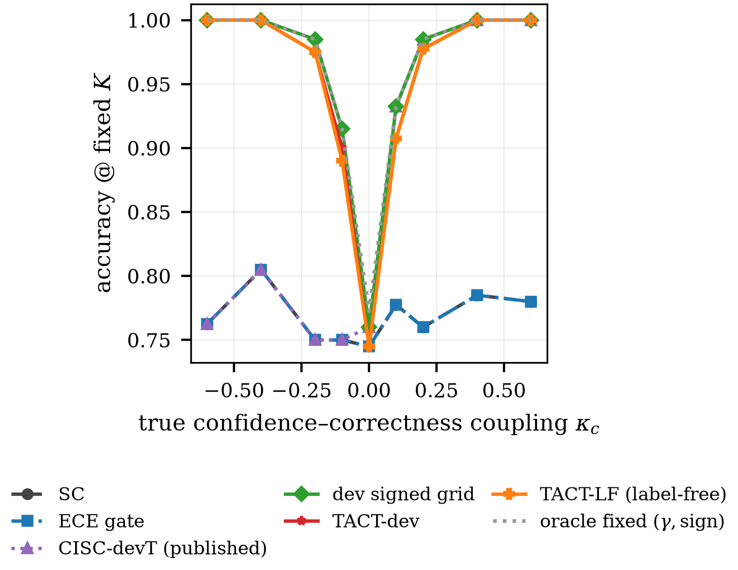
Main result on the confidence-usage frontier. tact-dev and the fully label-free tact-LF track the signed oracle across the sweep; CISC-devT and the ECE gate sit at the sc floor for all $κ<0$.

Results
Coupling sweep (accuracy at $K=15$; $400$ paired items per cell; dev $n=200$). Published protocols sit at the sc floor on the entire negative half-axis.
$κ$ | sc | ECE | devT | SignGrid | tact-dev | tact-LF | oracle
$−0.6$ | .762 | .762 | .762 | 1.000 | 1.000 | 1.000 | 1.000
$−0.4$ | .805 | .805 | .805 | 1.000 | 1.000 | 1.000 | 1.000
$−0.2$ | .750 | .750 | .750 | .985 | .975 | .975 | .985
$−0.1$ | .750 | .750 | .750 | .915 | .900 | .890 | .915
$0.0$ | .745 | .745 | .760 | .760 | .745 | .745 | .772
$+0.1$ | .777 | .777 | .932 | .932 | .907 | .907 | .932
$+0.2$ | .760 | .760 | .985 | .985 | .978 | .978 | .985
$+0.4$ | .785 | .785 | 1.000 | 1.000 | 1.000 | 1.000 | 1.000
$+0.6$ | .780 | .780 | 1.000 | 1.000 | 1.000 | 1.000 | 1.000

Signed recovery, with and without labels
Table 1 and Fig. 2 give the sweep. Three observations. First, the published protocols never leave the floor on $κ<0$: CISC-devT’s grid is positive-only and the ECE gate never opens (dev ECE ranges $0.10$–$0.80$ across the sweep while the signal’s discrimination is perfect at the extremes). Second, the label-free variant matches the $200$-label variant nearly point-for-point—at $κ=−0.6$ the raw agreement statistic is ${\hat{D}}_{g}=−0.81$ with $z=−17.6$, and the CCN identity’s sign guarantee holds as predicted, yielding $1.000$ with zero labels. Third, at $κ=0$ the dead zone returns $γ=0$ exactly, so the paired accuracy difference to sc is identically zero—“non-inferior” is replaced by “identical.”
Adversarial regimes (accuracy at $K=15$). “Oracle” is the test-set best over raw-value weight policies; rank invariance beats that entire family under compression.
Regime | sc | devT | SignGrid | tact-dev | tact-LF
Monotone compress | .775 | .963 | .963 | 1.000 | 1.000
Monotone overconf | .775 | 1.000 | 1.000 | 1.000 | 1.000
Monotone power | .775 | 1.000 | 1.000 | 1.000 | 1.000
Hetero (i.i.d.) | .765 | .765 | .765 | .765 | .765
Confident echo | .190 | .190 | .568 | .615 | .190$​^{†}$
$​^{†}$alarm fires and the method refuses to leave sc: the conditional guarantee of Prop. 4 working as stated.
Where the derived exponent actually operates. The four cells that carry the headline $1.000$ ($κ=±0.4,±0.6$) are cells where $\hat{D}$ saturates, so the link returns an untempered $γ^{*}$ between $−8.4$ and $+12.1$ across the seven saturated cells and the cap $γ_{max}=4$ is what the vote actually sees; the derived magnitude is not doing the work there, the sign is. Conversely, at $κ=±0.1,±0.2$, where the derived value lands strictly inside the cap ($|γ|$ from $1.10$ to $2.91$), tact-dev trails the dev-picked signed grid on all four cells ($0.900$ vs. $0.915$; $0.907$ vs. $0.932$; $0.975$ vs. $0.985$; $0.978$ vs. $0.985$). Read together: against the published protocols the advantage is large and comes from representing the sign at all, whereas against a signed grid the analytic map is not better at choosing a magnitude on these cells. Its advantage over the grid is elsewhere, in the three cells named in C4, and the one place the interpolation itself pays is confident echo, where $γ=−1.198$ falls between grid points and beats the grid optimum $γ=−1$ ($0.615$ vs. $0.568$).

Rank invariance where raw values fail
Under monotone compression (Table 2, Fig. 3) all confidences huddle near $0.5$, so every $c^{γ}$-family weight is nearly uniform: even the oracle over raw-value policies reaches only $0.963$. tact’s rank scores are untouched by the distortion and both variants reach $1.000$. Under the confident echo, dev labels reveal the inversion (high confidence $⇒$ wrong) and tact-dev counters with $γ=−1.20$, the best result in the field ($0.615$; $3.2×$ the sc floor); label-free, the duplicate-collapse alarm fires and the method correctly refuses—by Proposition 6 no label-free method could do better than a coin flip on the sign here, since $88\%$ of the cell’s items are effectively binary and the escape the proposition identifies is unavailable on them; pretending otherwise would be the real failure.
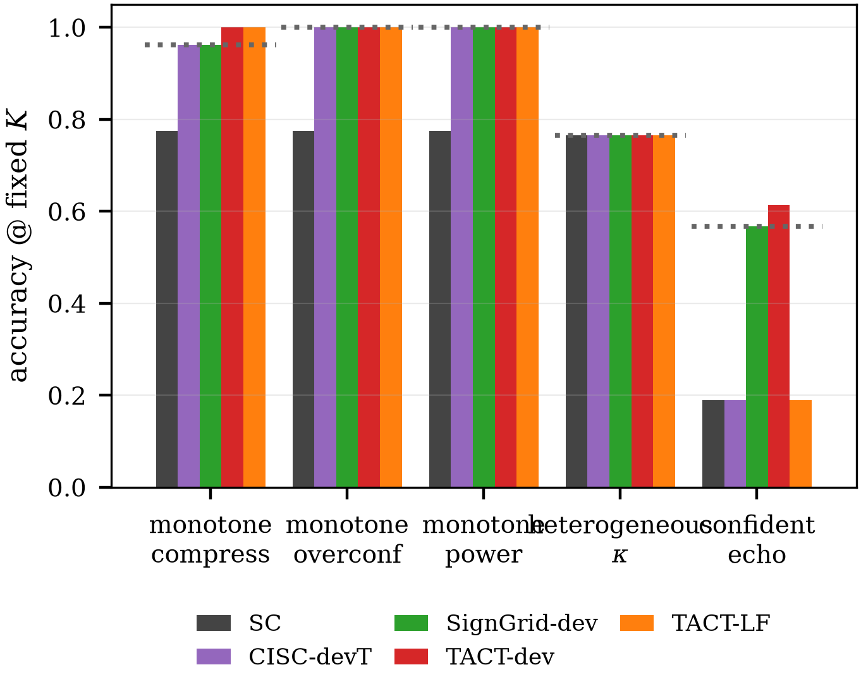
Adversarial regimes. Dotted line: the oracle over raw-value weights. Left group of bars: rank invariance beats that family under compression; right: the labeled variant counters the confident echo while the label-free variant alarms and refuses.

Heterogeneity
Table 3 and Fig. 4 give the group study. In the covariate-structured cell, per-group tact recovers each group’s signed coupling (dev $\{+4.0,0.0,−4.0\}$, label-free $\{+2.0,0.0,−2.0\}$, the $κ=0$ group correctly dead-zoned—and cracks the floor that provably binds every global policy: the label-free variant reaches $0.923$, within $0.023$ of the per-item link oracle, with zero paired losses to sc over $600$ items ($+83/−0$, $p=2.1×{10}^{−25}$). In the i.i.d. cell every method sits at the floor with zero discordant pairs, the naive self-referential control included: it cannot beat the plurality it is derived from. That control is the empirical face of Propositions 5–6, and the grouped cell is where it shows: given the same covariate the per-group estimator exploits, it reaches $0.787$ against the $0.785$ floor, two items in $600$. The two arms land within seed noise of each other here ($0.923$ and $0.927$ on one seed; $0.929±0.015$ each over five). A natural explanation would be the arms’ different exponent caps; the ablation rules it out. Sweeping the cap over $\{1,2,3,4,6,8\}$ moves neither arm at all (spread $0.0000$ for both), so the cap is not load-bearing in this cell and the difference is sampling variation.
Heterogeneity study ($600$ paired items; $K=15$).
Method | Grouped | i.i.d.
sc (floor) | .785 | .752
tact global (dev) | .785 | .752
tact-group (dev) | .927 | .752
tact-group (label-free) | .923 | .752
Naive per-item (neg. control) | .787 | .752
Per-item link oracle (ceiling) | .947 | .973
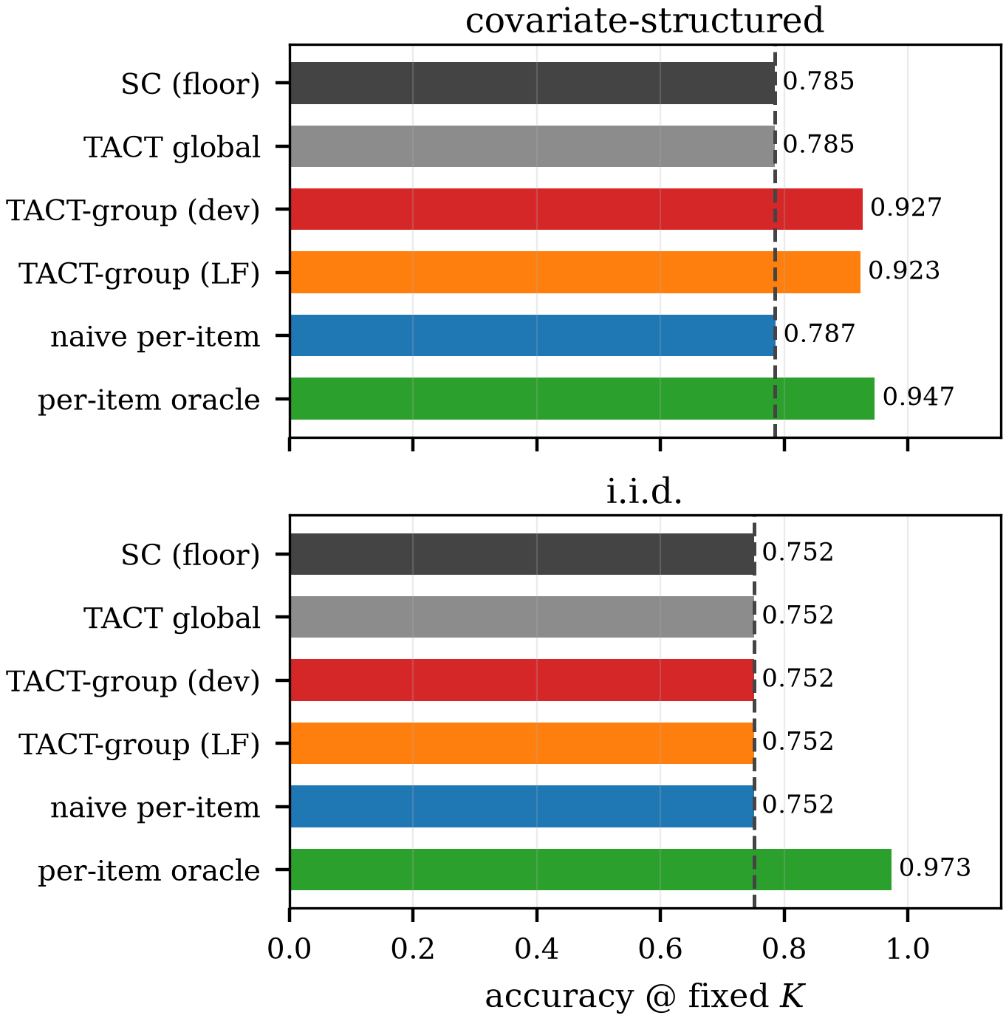
Structured vs. i.i.d. heterogeneity. Left: with an observable covariate, per-group tact (label-free) approaches the per-item oracle from the $0.785$ floor with zero losses to sc. Right: the provably closed i.i.d. cell—every method at the floor, the negative control included.

Small dev sets and falsifiers
With dev $n=50$ the conclusions are unchanged ($1.000$ at $|κ|=0.6$; $0.978$ at $−0.2$): the SE-aware shrinkage degrades smoothly rather than catastrophically. All four falsifiers survived: F1 ($1.000$ vs. $1.000$), F2 (bit-identical at $κ=0$; nowhere more than the pre-registered $0.02$ accuracy tolerance below sc), F3 (sweep means $0.944$ vs. $0.768$), and F4 (both grid baselines trail by $0.037$ and $0.047$ on the distortion and echo cells, and neither can operate without labels). On the single seed the paired tests against SignGrid-dev are not significant anywhere ($κ=−0.2$: $3/7$ discordant, exact $p=0.34$; $κ=+0.1$: $8/18$, $p=0.08$), and the ten-seed intervals of Section 8.6 are what establish the mid-range deficit. Against SignGrid-dev the honest margin is narrow on the homogeneous sweep—tact even trails by $0.007$–$0.025$ in the mid-range, the deliberate cost of shrinkage—and the net advantage concentrates exactly where pre-registered: distortion ($+0.037$), echo ($+0.047$), and label-free operation, which no grid can perform.

Verification of the implementation
Because every claim in Sections 4–6 is a mathematical property rather than an empirical trend, the released code pins each one with an executable test; the suite is 102 tests covering tact and the follow-on work. Table 4 maps propositions to the tests that would fail if they stopped holding.
What the test suite verifies. Every proposition in the paper has an executable counterpart; the counter-tests fail deliberately on rejected alternatives so a regression cannot silently reinstate them.
Claim | Evidence
Prop. 1 (exact sc) | identical incl. ties, 200 pools; dead-zone rate $>$70% under $D=0$
Prop. 2 (exact CISC) | identical vote shares, 100 pools
Prop. 4 (attenuation) | $ρ∈\{.1,.25,.4\}$, abs. $.06$
Props. 5–6 | 97.5% sc agreement; 4% sign match; the two-world boundary is pinned both ways (binary pools indistinguishable, a populated third cluster separates them at $KS p<{10}^{−10}$)
Rank invariance | 3 distortions $×$ 100 pools
Estimator internals | permutation null variance (3,000 draws, 10% tol.), JS–EB identity to ${10}^{−12}$, link [eq:link] to rel. ${10}^{−9}$, permutation-invariance regression
Rejected alternatives | Kish ESS and the SAFE-under-VoI guarantee each have a test asserting their failure
Two entries deserve comment. The permutation-invariance test was added after a defect in which the memoisation key made the test pass while the estimator itself was order-dependent by up to $0.10$; it now calls the internal routine directly. And the last two rows are counter-tests that assert failure of rejected alternatives — the Kish effective-sample-size formulation and the claim that the shipped default honours the SAFE stopping guarantee — so that neither can be silently reinstated by a later change.

A harness artifact, and dispersion across seeds
Two corrections to the synthetic results, both found by re-running what had been single-seed measurements.
Tie-breaking was rewarding sc for free. The generator assigned the correct answer the code $0$ on every item, and argmax breaks ties toward the lowest index, so on any item whose vote was tied plain sc chose correctly by construction: $67.7\%$ on near-tied items against $50.4\%$ for a random tie-break, with $31.8\%$ of items tied at $K=15$. Every method that perturbs the weights off integers forfeits that subsidy, so the artifact inflated the baseline and penalised the proposed method. It also produced a spurious falsifier: at $κ=0$, tact-dev averaged $0.797$ against sc at $0.818$ across ten seeds, tripping F2, while the exponents responsible were $|γ|≤0.05$. The items were near-ties whose tie-break had moved, not items the exponent had reweighted. Answer codes are now permuted per item. With the artifact removed the two coincide exactly where the dead zone should hold: $κ=0$ gives $0.745$ for both methods and heterogeneous-$κ$ gives $0.765$ for both (ten-seed means $0.758$ and $0.768$, zero discordant pairs in every seed): the dead zone behaves as Proposition 1 states. All synthetic numbers in this paper are post-fix.
Dispersion. Ten seeds per cell, $400$ paired items each, bootstrap over seeds. The extremes are stable to the third decimal ($1.000±0.001$ at $|κ|≥0.4$). The mid-range deficit against SignGrid-dev is small but real rather than noise: $−0.013$ $[−0.017,−0.009]$ at $κ=−0.2$, $−0.016$ $[−0.024,−0.009]$ at $−0.1$, $−0.012$ $[−0.018,−0.005]$ at $+0.1$, $−0.013$ $[−0.019,−0.008]$ at $+0.2$, all $p<0.001$. So is the advantage where the paper claims it: $+0.032$ $[+0.027,+0.037]$ on monotone compression and $+0.048$ $[+0.037,+0.059]$ on confident echo. The one cell that changes sign under the fix is heterogeneous-$κ$, now $+0.011$ $[0.000,+0.031]$ rather than a loss. Reporting a single seed would have hidden both the artifact and the fact that the mid-range gap is systematic.

Real-trace validation
Validation on real traces used Claude Haiku 4.5 as the frozen model: 100 items, 50 from GSM8K [23] and 50 from CommonsenseQA, with 12 independent chain-of-thought traces and a verbalized confidence per item (1,200 traces total), evaluated at $K=12$ with a 40/60 dev/test split. Four findings.
(a) The calibration–discrimination distinction reverses on real data, and tact reads it correctly. The channel is extremely well calibrated in the usual sense: $ECE=0.016$, far inside the $0.10$ gate, so a binary ECE gate opens and hands the channel to CISC. Yet the measured within-item discrimination is $\hat{D}=−0.219$ with $SE=0.176$ ($z=−1.24$): no usable signal, and what little there is points the wrong way (math $−0.515$, commonsense $−0.173$; both groups negative). This is the exact mirror image of the synthetic case in which ECE wrongly closed the gate on a discriminative channel (Section 3): on real traces ECE wrongly opens it on a non-discriminative one. Calibration is uninformative about voting utility in both directions, and a signed discrimination statistic is what distinguishes them.
(b) The dead zone fires, and costs exactly nothing. With $|z|<ν$, tact-dev, tact-LF and tact-group all return $γ=0$ and are bit-identical to sc on every test item ($+0/−0$ discordant pairs, $p=1$). All methods score $0.917$. This is the pre-registered null-direction prediction of Section 9 confirmed on real data: where the channel carries no signal, the method is free.
(c) Saturation is the binding constraint, not the estimator. Trace-level accuracy is $0.958$ on GSM8K and $0.847$ on CommonsenseQA, so only $12$ of $100$ items contain both a correct and an incorrect trace, the only items a within-item rank statistic can use. The estimator is not underpowered by design; the benchmark simply does not present the model with enough genuine uncertainty. Exposing non-null coupling on a strong model requires harder item pools, not more traces per item.
(d) Verbalized confidence is tie-heavy. Two values ($0.99$, $0.95$) account for $49\%$ of all reports, activating the tie-safe degeneration path of [eq:vdw] on many items.
(e) The abstention is a measurement, and a fragile one here. A rule that never acts reproduces (b) exactly, so the campaign on its own separates a working safety mechanism from an absent signal not at all. Three replays of the same cached pools separate a little more. Stability: bootstrapping the items, the dev gate opens in $50.4\%$ of resamples—with $|z|=1.24$ against $ν=1.28$ the reported abstention is a $3\%$ margin, not a reading of the evidence—while the label-free gate opens in $16.2\%$—though finding (f) will show that figure describes the significance gate alone. Specificity: permuting confidences within items, which preserves the real marginals, ties, pool composition and difficulty and destroys only the coupling, puts the false-open rate at $18.4\%$ against a nominal $20\%$ ($1.6\%$ against $2\%$ label-free), with the null $z$ at mean $−0.002$ and SD $0.954$. The dead zone’s null behaviour is therefore calibrated on the real substrate and not only on the generator it was derived from, which is the one piece of evidence here that the mechanism is doing work. Cost: overriding the gate, the derived $γ=−0.40$ would have scored $0.933$ ($+1/−0$) and a gold-label oracle reaches $0.950$ at $γ=−1.25$, a ceiling of two items. Neither approaches significance, so the substrate is null in the way that matters; but the sign the estimator derived is the sign the oracle wanted, and (b) should be read as costs nothing measurable at this $n$ rather than as a demonstration that abstaining was right.
(f) What the gate could have detected here. Finding (e) measures specificity; sensitivity needs a channel of known strength, so one is planted into these same pools—real answers, difficulty and duplication untouched, only the confidence vector replaced, conditioned on the real correctness pattern. Planting only the estimator’s own location-shift model would prove nothing (the invariance-group pitfall of Section 9), so four families are swept: the Gaussian location shift; the same shift under Laplace noise, violating the link’s normality assumption while preserving $D$; a rank-concentrated channel that forces the top-confidence slot onto a correct trace; and a variance-only channel, informative but unsigned. Four results, $40$ seeds per cell. One: the gate’s operating characteristic is a function of the realized $|\hat{D}|$ and not of the family—half-power near $|\hat{D}|=0.247$ (Gaussian) and $0.208$ (Laplace), full power by $0.49$ and $0.56$, and the derived exponent capturing the whole oracle gain from $0.83$ and $0.95$; at the Gaussian thresholds the Laplace family is already at $0.975$ power and $0.98$ capture—so detection is a property of the rank functional rather than of the generator, and the link survives the normality violation. The measured channel of (a), $|\hat{D}|=0.219$, sits at the half-power floor: finding (e)’s coin flip restated as an operating characteristic. Two: conditional on the gate opening, the sign is never wrong, in any cell of any family. Three: the scope boundaries are real. The rank-concentrated channel yields $|\hat{D}|≤0.183$ at full strength—a pooled pair statistic barely sees information carried by a single rank position—and leaves the derived gain near zero where a gold-label exponent takes $+0.039$; the unsigned channel is invisible by construction and the gate correctly holds its nominal false-open rate on it. Four, a defect: the label-free arm never acts in any cell, even on a saturating channel with the item floor lowered to one, because with $85$ of $100$ items unanimous the margin gate’s $40\%$-quantile cut equals $1.0$, and no item satisfies margin $≥1.0$ with two distinct answers. Its abstention in (b) was therefore structural rather than a reading of the channel, and on saturated substrates the quantile gate needs an absolute cut.
Scope of this first campaign: one model, two benchmarks, $K=12$. It confirms the null-direction prediction and the calibration–discrimination argument, and it is not evidence that tact improves accuracy, since the channel carried no signal to exploit. Finding (c) predicts what to do about that, and Section 8.8 does it.

Confirmatory campaign on harder items
Finding (c) predicts that a channel measured as null on saturated benchmarks should become measurable on items the model finds genuinely uncertain. A pre-registered follow-up tests that prediction: $119$ MATH level-5 problems [24,25], $16$ traces each from the same frozen model, a $30$-item sign set and an $89$-item evaluation set drawn from the registered list before any trace was collected, and five hypotheses (H1–H5) fixed in advance.
The channel is real. On the evaluation set the pooled statistic is $\hat{D}=+0.250$ with $SE=0.098$, so $z=+2.54$ and H1 passes. This is the first real-trace evidence that verbalized confidence carries positive within-item discrimination; the same measurement on GSM8K/CommonsenseQA gave $−0.219$ ($z=−1.24$).
The endpoint was unpassable for any method. The realized substrate saturated again: per-trace accuracy $0.819$, sc $0.888$, a decisive stratum of $10$ of $89$ items, and the correct answer present in the pool on only $4$ of those. The in-pool oracle therefore tops out at $+4/−0$, exact one-sided $p=0.0625$. H2 fails, but it fails for every conceivable aggregation method including a perfect one, so the failure is a property of the substrate rather than of the estimator.
Abstention behaved as designed. tact returned $γ=0$, with alarms E4 and E2 firing on the label-free path and the sign set holding too few informative items to supply a semi-label-free sign. The vote is therefore bit-identical to sc at $0.888$ (H3, H4 pass). The cost of acting anyway is visible in the same table: best-single-confidence, the trivial baseline that always trusts the channel, loses $4.5$ points at $0.843$. E4 is an item-supply condition rather than a reading of the channel, and finding (f) shows it has two routes: on the saturated pools of Section 8.7 the margin gate’s quantile cut degenerates to $1.0$ and the gated set is empty for any channel, whereas here the cut is $0.875$ and the set is non-empty, so the alarm reports a genuine shortfall against the floor rather than a collapse. Only the first is a defect.
Confirmatory campaign, MATH level-5 evaluation set ($89$ items, $K=16$). Every method replays the same cached pools. The duplication channel is inert because no reasoning text was collected, so dedup-sc coincides with sc by construction.
Method | Accuracy | net vs. sc
sc / dedup-sc / CISC-linear | $0.888$ | —
tact-LF | $0.888$ | $+0/−0$
tact-semi-LF | $0.888$ | $+0/−0$
best-single-confidence | $0.843$ | $+1/−5$
in-pool oracle (ceiling) | $0.933$ | $+4/−0$
One caveat from this campaign transfers beyond tact. Measured difficulty depended on the collection protocol: a $30$-problem-per-call probe put level-5 plurality accuracy at $0.40$, while the $15$-problem-per-call confirmatory run yielded $0.888$ on the same stratum. Batch size belongs in the experimental record whenever traces are collected in batches.

How wide is the addressable stratum?
Both campaigns failed their endpoint for the same reason, which suggests measuring that reason directly. Define the window as the fraction of items where the plurality is wrong and the correct answer is present in the pool: the ceiling for any label-free aggregation method, since nothing outside it can be changed.
The window was measured on five substrates spanning two domains (Table 6). For code generation, where an executable test suite supplies per-sample ground truth and the window might reasonably be expected to widen, $40$ LeetCode Medium/Hard problems [26] were solved $8$ times each and graded against the benchmark’s hidden suites, with the baseline taken as the largest behavioural cluster over probe inputs (never expected outputs). The window is $3/40=7.5\%$ (CI$​_{95}$ $2.6$–$19.9\%$): wider than label-free QA, but the same order, and the composition is the same shape at $30$ saturated, $7$ capability wall and $3$ rescuable, i.e. $75/17.5/7.5\%$. Nor does budget open it. The seven capability-wall problems produced zero correct solutions in $224$ further attempts (per-problem $95\%$ upper bound on the pass rate $0.088$), and extrapolating oracle@$N$ shows the window saturating by $N=32$.
The addressable stratum across substrates, on one definition throughout: decisive is the fraction of items whose plurality is wrong, window (Win.) the fraction that are decisive and have the correct answer somewhere in the pool; both in per cent. The window is the ceiling for any label-free aggregation method. Rows marked $†$ are measured here; HumanEval+/MBPP+ is recomputed from published oracle-minus-selector tables, which report the window only. As items harden the decisive fraction grows but the window does not: they pass from saturated to capability-limited. The MATH L5 row is over the full registered list of $119$ items, the substrate being the object measured; Section 8.8 quotes the same quantities over the $89$-item evaluation set that remains after the sign set is split off ($10$ and $4$ items, so $11.2$ and $4.5$). The last row is that same MATH L5 substrate under the budget manipulation of Section 8.10, not a sixth substrate: the $2.5$–$7.5\%$ range quoted throughout is over the five above it.
Domain | Substrate | Dec. | Win.
QA | GSM8K / CSQA$​^{†}$ | $9.0$ | $4.0$
QA | MATH L5$​^{†}$ | $7.6$ | $2.5$
QA | AIME / AMC$​^{†}$ | $23.3$ | $3.3$
Code | HumanEval+ / MBPP+ | — | $3.6$
Code | LeetCode Med/Hard$​^{†}$ | $25.0$ | $7.5$
QA, budget-capped | MATH L5$​^{†}$ | $18.5$ | $11.8$
One precaution belongs with these numbers, because omitting it would have inverted them. The grading harness was validated against the benchmark’s own reference solutions before any candidate was scored: $178$ of $180$ pass under the sandbox’s resource limits. The check is not a formality: a sandbox whose resource limits the host rejects outright fails $100\%$ of executions, and that condition presents as a candidate failure rather than as an error. Studies that grade by execution should report their reference-solution pass rate for the same reason a calibration curve is reported: without it, a broken harness and a capability wall look identical.

A third axis: reasoning budget
Difficulty is not the only way to lower per-sample accuracy. Constraining the reasoning budget lowers it while leaving the correct answer inside the model’s competence, which is the combination the decisive stratum needs and that difficulty does not supply: as items harden they pass from saturated to capability-limited without pausing in between. A paired run tests this on the same $119$ items, same model, same $K$, with the model instructed to answer without writing any working.
The manipulation was weaker than pre-registered on its stated check (per-sample accuracy $0.853→0.781$, against a $0.10$ drop required) and the correct answer did not leave the pool ($0.950→0.933$), so what follows is exploratory. It is reported because the constraint did not lower accuracy uniformly, it moved items across the plurality boundary: sc fell $0.924→0.815$, the window widened from $2.5\%$ to $11.8\%$ (paired exact McNemar on window membership, $13$ in and $2$ out, $p=0.0037$), and the channel grew stronger, $\hat{D}$ from $+0.229$ ($z=2.69$) to $+0.398$ ($z=6.76$). Forced to answer without working, the model’s confidence tracks whether it happened to be right.
This is the widest window measured anywhere in this paper, and the first substrate on which the in-pool oracle clears the endpoint at all ($+9/−0$, $p=0.002$ on a decisive stratum of $17$). tact nonetheless returned $γ=0$: only $12$ items survived the margin gate against the threshold of $30$, so E4 fired—the same item-supply condition, with the quantile cut at $0.750$ and the gated set again non-empty, and not the degenerate case finding (f) reports. That abstention is testable rather than a matter of taste, and it cost nothing. Estimating $γ$ from gold labels, an upper bound no deployable method has access to, the best available is $+4/−1$ at $γ=1$ ($p=0.19$); the derived $γ=0.670$ gives $+3/−1$. The gap that matters is therefore not the one the window closes. Even with the window at $11.8\%$ and an oracle able to convert nine items, confidence weighting reaches fewer than half of them, and none of the reachable configurations is significant.

Discussion and Limitations
What the evidence does and does not show. The accuracy claims are all on a synthetic oracle whose confidence model [eq:confmodel] is, at the homogeneous cells, the very coupling the estimator measures. Three design choices limit the circularity, and the first is weaker than it looks: heterogeneity and echo lie outside the estimator’s working model, but the three distortion cells are rank-preserving by construction and therefore sit inside tact’s own invariance group, so passing them tests that the implementation respects an invariance it was built to have rather than probing an untested regime; mechanism-recovery claims (does $\hat{D}$ track $κ$?) are reported separately from accuracy claims; and the pre-measured baseline landscape (Fig. 1) fixed the winnable cells before the method existed. The real-trace campaigns of Sections 8.7 and 8.8 test the premise and the abstention behaviour, and both predictions held: the channel is null on saturated benchmarks and positive on competition mathematics, and the dead zone kept the vote bit-identical to sc in each case. They do not test the accuracy claim, because on neither substrate was the addressable stratum large enough for any method to demonstrate a gain (Section 8.9).
Narrow margins where labels abound. When labels are plentiful and the confidence scale is trusted, a dev-picked signed grid captures most of the value; tact’s case rests on the label-free setting, distorted scales, small dev sets, and the exactness of its anchors.
Conditional label-free guarantee, and what happens past the boundary. Proposition 4 requires $\overset{‾}{ρ}<1/2$ after deduplication, and the confident-echo ambiguity is fundamental (Proposition 6). Follow-on work measured the consequence of crossing that boundary, and it is worse than under-trust. In a paraphrased wrong-majority cell (a dominant wrong cluster that is semantically tight but carries no verbatim signature, so deduplication has nothing to collapse) the plurality is wrong on most items, $\overset{‾}{ρ}>1/2$, and tact-LF does not merely shrink toward sc: it mis-signs, saturates at $γ=−2.0$, and scores $0.000$ against an sc floor of $0.340$. None of the four alarms fires, because E1 keys on verbatim duplication which is absent by construction. This is the method’s sharpest unguarded failure mode: the guarantee is conditional, the condition is not observable label-free, and the existing diagnostics do not detect its violation. Where a systematically wrong majority is plausible, the semi-label-free mode (sign from $∼50$ labels) should be the default rather than an optional refinement. The other standard remedy is not tried here and should be: the failure is driven by a semantically tight wrong cluster that lexical deduplication cannot see, which is precisely what semantic-equivalence clustering [27] is built to collapse. Substituting a semantic pseudo-label for the lexical one is the obvious next guard, and this paper does not test it.
Global exponent per group. Within a group, tact ships one exponent; per-item variation inside a group is unexploitable by Propositions 5–6 unless further covariates exist.
The thin window. Section 8.9 measures the stratum this whole family of methods can act on at $2.5$–$7.5\%$ of items across all five substrates, in two domains, with no widening as items harden: they pass from saturated straight to capability-limited. Two consequences follow for the method proposed here. First, abstention is not a conservative compromise but the only correct default, and the measured cost of acting anyway was negative on both real substrates (best-single-confidence loses $4.5$ points in Table 5 where the dead zone holds tact at the sc floor). Second, an aggregation gain of the size reported on the synthetic harness is not measurable on a benchmark of a few hundred items at these window widths, which is why the real-trace claim in this paper is confined to the premise (the channel exists and is signed) and to the abstention behaviour, and does not extend to accuracy. Demonstrating the gain needs a (model, benchmark) pair whose plurality is wrong on $30$–$60\%$ of items with the correct answer still reachable, and no pair tried here satisfies both. Section 8.10 adds the one axis that does widen the window, and it cuts the same way: with the window at $11.8\%$ and an oracle able to convert nine items, confidence weighting still reaches fewer than half of them. The width of the window is not the only thing in the way.
Widening the window on purpose. That result also names the most promising direction the paper does not pursue. Difficulty moves items from saturated straight to capability-limited, but the budget constraint of Section 8.10 moved them across the plurality boundary while leaving the answer inside the model’s competence, which is the combination the decisive stratum needs; sampling temperature is a second knob with the same character, and neither was swept. If the sampling regime is a controllable input rather than a fixed property of the substrate, the question changes from “how wide is the window?” to “what decoding configuration puts the most items in it, at what accuracy cost, and does the confidence channel stay signed there?” The budget arm answers the first part once and suggests the channel gets stronger under the constraint ($\hat{D}$ from $+0.229$ to $+0.398$), which would be worth confirming on more than one substrate before it is believed. A method that chose its own decoding budget to maximise decisive-stratum mass, then aggregated, would be a different contribution from this one, and the measurement here is what makes it worth attempting.

Conclusion
tact turns “how far should this model’s confidence be trusted?” into a measured, signed, uncertainty-aware scalar, and recovers the sign without labels under conditions this paper states and tests. The measurement that frames it matters more than the estimator: across five substrates in two domains, the stratum on which any label-free aggregation method can act is $2.5$–$7.5\%$ of items, and on both real substrates the in-pool oracle cannot clear a pre-registered endpoint. In that regime the useful property of an estimator is knowing when not to act, which the dead zone does exactly.

Code and Data Availability
All code, cached traces, and the JSON artifacts behind every table are at https://github.com/vito1317/adaptive-reasoning-consensus. Table 4 is produced by pytest at commit 35ad160; the synthetic results by experiments/run_tact_eval.py, the real-trace campaigns by run_tact_hard_eval.py, and the window measurements by run_g1_window.py and run_g1_deepening.py; the three abstention replays of finding (e) by run_abstention_identifiability.py; the planted-channel operating characteristic of finding (f) by run_planted_sensitivity.py. Each script writes the artifact its table cites. Figures 1–4 are vector output from experiments/make_paper_figures.py, which reads the same JSON.

Notation
Symbols, in order of first use. Quantities carrying a subscript $q$ are per item; the estimator ships one global scalar unless a group covariate is available (Section 6).
Symbol | Meaning
$q$, $Q$ | item index; number of items
$m_{q}$, $K$ | traces available for item $q$; voting budget
$a_{q,i}$, $a_{q}^{*}$ | answer of trace $i$; the correct answer
$c_{q,i}$ | self-reported confidence, in $(0,1)$
$y_{q,i}$ | $1[a_{q,i}=a_{q}^{*}]$; unobservable at test time
$\overset{‾}{p}$ | base rate of correct traces
$R_{q,i}$ | within-item midrank of $c_{q,i}$ (ties averaged)
$φ_{q,i}$ | standardized van der Waerden score of $R_{q,i}$; the vote feature
$σ_{q}$ | realized within-item SD of the normal scores
$γ$, $γ_{max}$ | vote exponent; its cap ($4$ dev, $2$ label-free)
${\hat{a}}_{q}$ | the returned answer
$D_{q}$ | Somers’ $D$ within item $q$, $=2 {AUC}_{q}−1=2 {WQD}_{q}−1$
$N_{q}$ | van Elteren pooling weight, $n_{q}^{1}n_{q}^{0}$
$\hat{D}$ | pooled signed discrimination
${SE}_{0}$, ${SE}_{J}$ | exact tie-corrected null SE; delete-one-item jackknife SE
$SE$ | $max\{{SE}_{0},{SE}_{J},1/(2\sqrt{N})\}$
$ζ$ | $\hat{D}/SE$; the dead zone is $|ζ|≤ν$
$ν$ | significance floor ($1.28$ dev, $2.33$ label-free)
$\tilde{D}$ | shrunk discrimination, $\hat{D}(1−ν^{2}/ζ^{2})_{+}$
$z$ | $Φ^{−1}​\left((1+\tilde{D})/2\right)$
$M_{q}$ | dedup-weighted plurality; the pseudo-label
$g_{q,i}$ | $1[a_{q,i}=M_{q}]$
$\overset{‾}{ρ}$ | pair-weighted probability the plurality is wrong
$\hat{η}$ | estimated attenuation $1−2\overset{‾}{ρ}$ (not $\overset{‾}{ρ}$)
$α$, $k$ | split-half agreement; effective number of wrong alternatives
$E_{1}…E_{4}$ | the four alarms; any one forces $γ=0$
$ψ$ | margin-decoupling statistic behind $E_{2}$
$κ_{c}$ | true confidence–correctness coupling in the oracle [eq:confmodel]
$λ_{q}$ | per-item coupling under i.i.d. heterogeneity

References
99
X. Wang, J. Wei, D. Schuurmans, Q. Le, E. Chi, S. Narang, A. Chowdhery, and D. Zhou, “Self-consistency improves chain of thought reasoning in language models,” in Proc. ICLR, 2023. https://arxiv.org/pdf/2203.11171
K. Tian et al., “Just ask for calibration: Strategies for eliciting calibrated confidence scores from language models fine-tuned with human feedback,” in Proc. EMNLP, 2023. https://aclanthology.org/2023.emnlp-main.330.pdf
M. Xiong et al., “Can LLMs express their uncertainty? An empirical evaluation of confidence elicitation in LLMs,” in Proc. ICLR, 2024. https://openreview.net/pdf?id=gjeQKFxFpZ
S. Kadavath et al., “Language models (mostly) know what they know,” arXiv:2207.05221, 2022. https://arxiv.org/pdf/2207.05221
A. Taubenfeld et al., “Confidence improves self-consistency in LLMs,” in Findings of ACL, 2025, arXiv:2502.06233. https://aclanthology.org/2025.findings-acl.1030.pdf
J. Kim, N. Yang, K. Min, and K. Jung, “Reliability-aware adaptive self-consistency for efficient sampling in LLM reasoning,” in Findings of ACL, 2026, pp. 21575–21590. https://aclanthology.org/2026.findings-acl.1085.pdf
Y. Fu et al., “Deep think with confidence,” arXiv:2508.15260, 2025. https://arxiv.org/pdf/2508.15260
X. Huang, S. Li, M. Yu, M. Sesia, H. Hassani, I. Lee, O. Bastani, and E. Dobriban, “Uncertainty in language models: Assessment through rank-calibration,” in Proc. EMNLP, 2024, pp. 284–312. https://aclanthology.org/2024.emnlp-main.18.pdf
A. P. Dawid and A. M. Skene, “Maximum likelihood estimation of observer error-rates using the EM algorithm,” J. Roy. Statist. Soc. C, vol. 28, no. 1, pp. 20–28, 1979. https://doi.org/10.2307/2346806
F. Parisi, F. Strino, B. Nadler, and Y. Kluger, “Ranking and combining multiple predictors without labeled data,” Proc. Natl. Acad. Sci., vol. 111, no. 4, pp. 1253–1258, 2014. https://pmc.ncbi.nlm.nih.gov/articles/PMC3910607/pdf/pnas.201219097.pdf
Y. Li et al., “Making language models better reasoners with step-aware verifier,” in Proc. ACL, 2023. https://aclanthology.org/2023.acl-long.291.pdf
P. Aggarwal, A. Madaan, Y. Yang, and Mausam, “Let’s sample step by step: Adaptive-consistency for efficient reasoning and coding with LLMs,” in Proc. EMNLP, 2023, pp. 12375–12396. https://aclanthology.org/2023.emnlp-main.761.pdf
Y. Li et al., “Escape sky-high cost: Early-stopping self-consistency for multi-step reasoning,” in Proc. ICLR, 2024. https://arxiv.org/pdf/2401.10480
Z. Kang, X. Zhao, and D. Song, “Scalable best-of-N selection for large language models via self-certainty,” in Proc. NeurIPS, 2025, arXiv:2502.18581. https://proceedings.neurips.cc/paper_files/paper/2025/file/1c7eff166a8e345f664f0faa8f4e4d2e-Paper-Conference.pdf
J. Whitehill et al., “Whose vote should count more: Optimal integration of labels from labelers of unknown expertise,” in Proc. NeurIPS, 2009. https://proceedings.neurips.cc/paper_files/paper/2009/file/f899139df5e1059396431415e770c6dd-Paper.pdf
D. R. Karger, S. Oh, and D. Shah, “Iterative learning for reliable crowdsourcing systems,” in Proc. NeurIPS, 2011. https://proceedings.neurips.cc/paper_files/paper/2011/file/c667d53acd899a97a85de0c201ba99be-Paper.pdf
J. Lee, V. Ma, S. Zhao, Y. Nair, A. Spector, R. Cohen, and E. J. Candès, “FUSE: Ensembling verifiers with zero labeled data,” arXiv:2604.18547, 2026. https://arxiv.org/pdf/2604.18547
R. Ai, Y. Pan, D. Simchi-Levi, M. Tambe, and H. Xu, “Beyond majority voting: LLM aggregation by leveraging higher-order information,” arXiv:2510.01499, 2025, accepted to ICML 2026. https://arxiv.org/pdf/2510.01499
P. van Elteren, “On the combination of independent two-sample tests of Wilcoxon,” Bull. Int. Statist. Inst., vol. 37, pp. 351–361, 1960. https://catalog.hathitrust.org/Record/008896012
W. James and C. Stein, “Estimation with quadratic loss,” in Proc. 4th Berkeley Symp. Math. Statist. Prob., 1961, pp. 361–379. https://digitalassets.lib.berkeley.edu/math/ucb/text/math_s4_v1_article-19.pdf
L. Kish, Survey Sampling. New York, NY, USA: Wiley, 1965. https://www.wiley.com/en-us/Survey+Sampling-p-9780471109495
J. N. K. Rao and A. J. Scott, “The analysis of categorical data from complex sample surveys,” J. Amer. Statist. Assoc., vol. 76, no. 374, pp. 221–230, 1981. https://doi.org/10.1080/01621459.1981.10477633
K. Cobbe et al., “Training verifiers to solve math word problems,” arXiv:2110.14168, 2021.
D. Hendrycks et al., “Measuring mathematical problem solving with the MATH dataset,” in Proc. NeurIPS Datasets and Benchmarks, 2021. https://datasets-benchmarks-proceedings.neurips.cc/paper/2021/file/be83ab3ecd0db773eb2dc1b0a17836a1-Paper-round2.pdf
H. Lightman et al., “Let’s verify step by step,” in Proc. ICLR, 2024. (MATH-500 test subset.)
Y. Xia et al., “LeetCodeDataset: A temporal dataset for robust evaluation and efficient training of code LLMs,” arXiv:2504.14655, 2025. https://arxiv.org/pdf/2504.14655
L. Kuhn, Y. Gal, and S. Farquhar, “Semantic uncertainty: Linguistic invariances for uncertainty estimation in natural language generation,” in Proc. ICLR, 2023. https://arxiv.org/pdf/2302.09664

